OSI Model

* OSI stands for **Open System Interconnection** is a reference model that describes how information from a software application in one computer moves through a physical medium to the software application in another computer.
* OSI consists of seven layers, and each layer performs a particular network function.
* OSI model was developed by the International Organization for Standardization (ISO) in 1984, and it is now considered as an architectural model for the inter-computer communications.
* OSI model divides the whole task into seven smaller and manageable tasks. Each layer is assigned a particular task.
* Each layer is self-contained, so that task assigned to each layer can be performed independently.

## Characteristics of OSI Model:

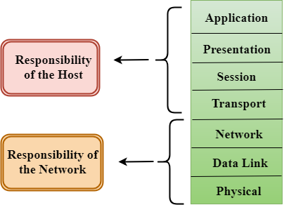

* The OSI model is divided into two layers: upper layers and lower layers.
* The upper layer of the OSI model mainly deals with the application related issues, and they are implemented only in the software. The application layer is closest to the end user. Both the end user and the application layer interact with the software applications. An upper layer refers to the layer just above another layer.
* The lower layer of the OSI model deals with the data transport issues. The data link layer and the physical layer are implemented in hardware and software. The physical layer is the lowest layer of the OSI model and is closest to the physical medium. The physical layer is mainly responsible for placing the information on the physical medium.

## Functions of the OSI Layers

There are the seven OSI layers. Each layer has different functions. A list of seven layers are given below:

1. Physical Layer
2. Data-Link Layer
3. Network Layer
4. Transport Layer
5. Session Layer
6. Presentation Layer
7. Application Layer

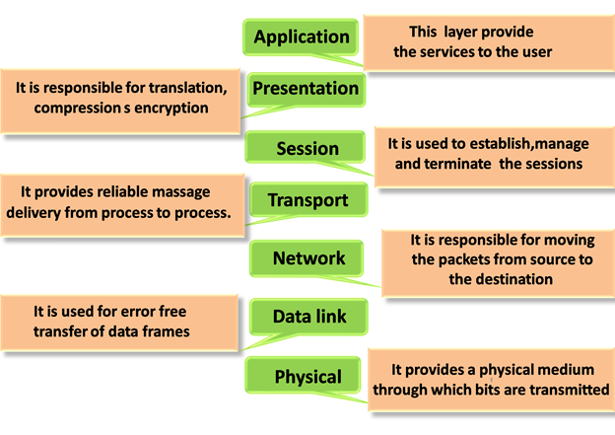

### Physical layer

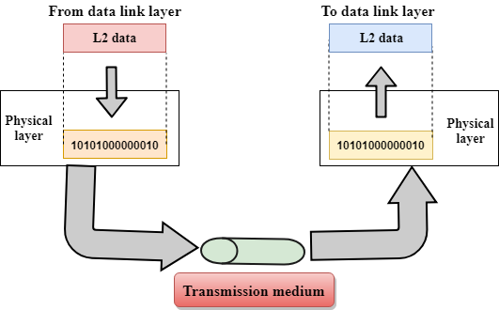

* The main functionality of the physical layer is to transmit the individual bits from one node to another node.
* It is the lowest layer of the OSI model.
* It establishes, maintains and deactivates the physical connection.
* It specifies the mechanical, electrical and procedural network interface specifications.

## Functions of a Physical layer:

* **Line Configuration:** It defines the way how two or more devices can be connected physically.
* **Data Transmission:** It defines the transmission mode whether it is simplex, half-duplex or full-duplex mode between the two devices on the network.
* **Topology:** It defines the way how network devices are arranged.
* **Signals:** It determines the type of the signal used for transmitting the information.

### Data-Link Layer

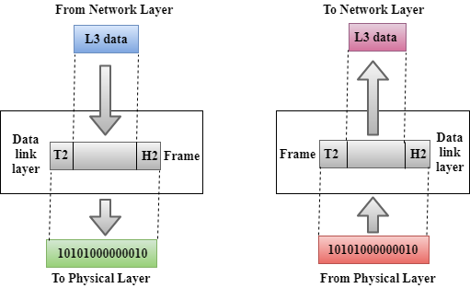

* This layer is responsible for the error-free transfer of data frames.
* It defines the format of the data on the network.
* It provides a reliable and efficient communication between two or more devices.
* It is mainly responsible for the unique identification of each device that resides on a local network.
* It contains two sub-layers:
  + **Logical Link Control Layer**
    - It is responsible for transferring the packets to the Network layer of the receiver that is receiving.
    - It identifies the address of the network layer protocol from the header.
    - It also provides flow control.
  + **Media Access Control Layer**
    - A Media access control layer is a link between the Logical Link Control layer and the network's physical layer.
    - It is used for transferring the packets over the network.

## Functions of the Data-link layer

* **Framing:** The data link layer translates the physical's raw bit stream into packets known as Frames. The Data link layer adds the header and trailer to the frame. The header which is added to the frame contains the hardware destination and source address.

OSI Model

* **Physical Addressing:** The Data link layer adds a header to the frame that contains a destination address. The frame is transmitted to the destination address mentioned in the header.
* **Flow Control:** Flow control is the main functionality of the Data-link layer. It is the technique through which the constant data rate is maintained on both the sides so that no data get corrupted. It ensures that the transmitting station such as a server with higher processing speed does not exceed the receiving station, with lower processing speed.
* **Error Control:** Error control is achieved by adding a calculated value CRC (Cyclic Redundancy Check) that is placed to the Data link layer's trailer which is added to the message frame before it is sent to the physical layer. If any error seems to occurr, then the receiver sends the acknowledgment for the retransmission of the corrupted frames.
* **Access Control:** When two or more devices are connected to the same communication channel, then the data link layer protocols are used to determine which device has control over the link at a given time.

### Network Layer

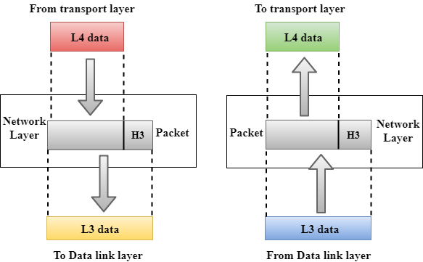

* It is a layer 3 that manages device addressing, tracks the location of devices on the network.
* It determines the best path to move data from source to the destination based on the network conditions, the priority of service, and other factors.
* The Data link layer is responsible for routing and forwarding the packets.
* Routers are the layer 3 devices, they are specified in this layer and used to provide the routing services within an internetwork.
* The protocols used to route the network traffic are known as Network layer protocols. Examples of protocols are IP and Ipv6.

## Functions of Network Layer:

* **Internetworking:** An internetworking is the main responsibility of the network layer. It provides a logical connection between different devices.
* **Addressing:** A Network layer adds the source and destination address to the header of the frame. Addressing is used to identify the device on the internet.
* **Routing:** Routing is the major component of the network layer, and it determines the best optimal path out of the multiple paths from source to the destination.
* **Packetizing:** A Network Layer receives the packets from the upper layer and converts them into packets. This process is known as Packetizing. It is achieved by internet protocol (IP).